EJERCICIOS BIG DATA—----smart data

1. SELECT pd.PRODUCTLINE, sum(td.SALES) as ventas_totales

from transaction_data td inner JOIN product_data pd ON td.PRODUCTCODE= pd.PRODUCTCODE

GROUP by pd.PRODUCTLINE

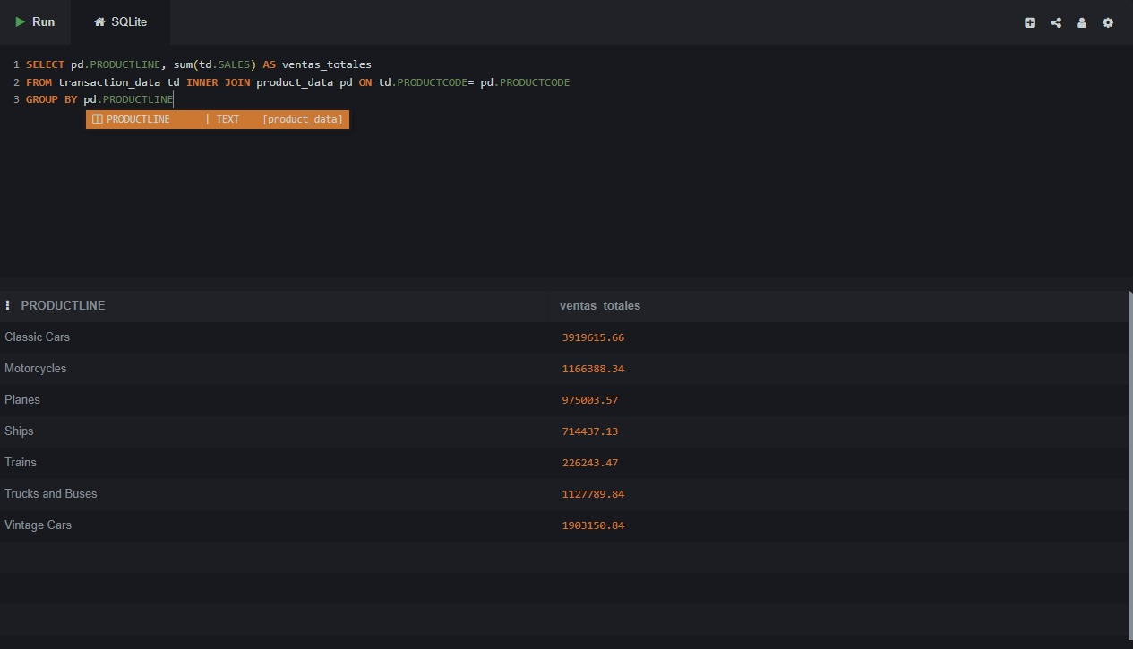

1. SELECT DISTINCT c.CUSTOMERNAME

FROM order_data o

JOIN transaction_data t

ON o.ORDERNUMBER = t.ORDERNUMBER

JOIN client_data c

ON t.CLIENT_ID = c.customer_id

WHERE o.STATUS = 'Disputed';

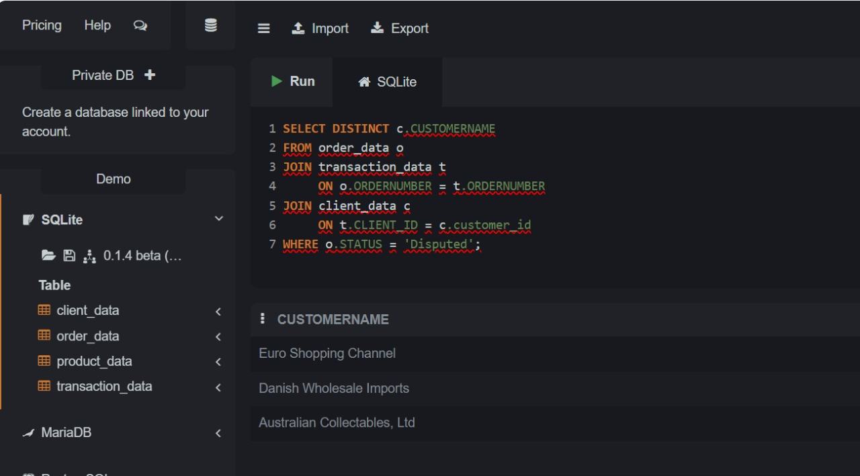

1. SELECT COUNT(DISTINCT o.ORDERNUMBER) AS pedidos_enviados_2003

FROM order_data o

JOIN transaction_data t

ON o.ORDERNUMBER = t.ORDERNUMBER

WHERE o.STATUS = 'Shipped'

AND t.YEAR_ID = 2003;

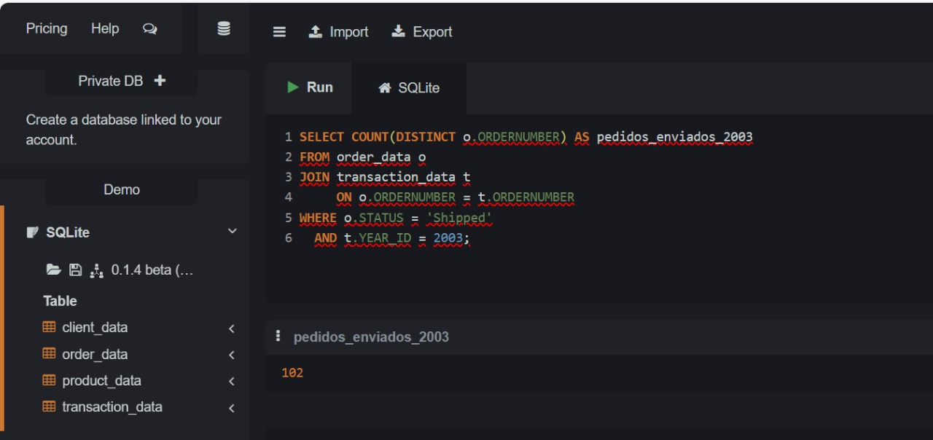

1. SELECT c.COUNTRY,

SUM(t.SALES) AS TotalSales

FROM transaction_data t

JOIN client_data c

ON t.CLIENT_ID = c.customer_id

GROUP BY c.COUNTRY

ORDER BY TotalSales DESC;

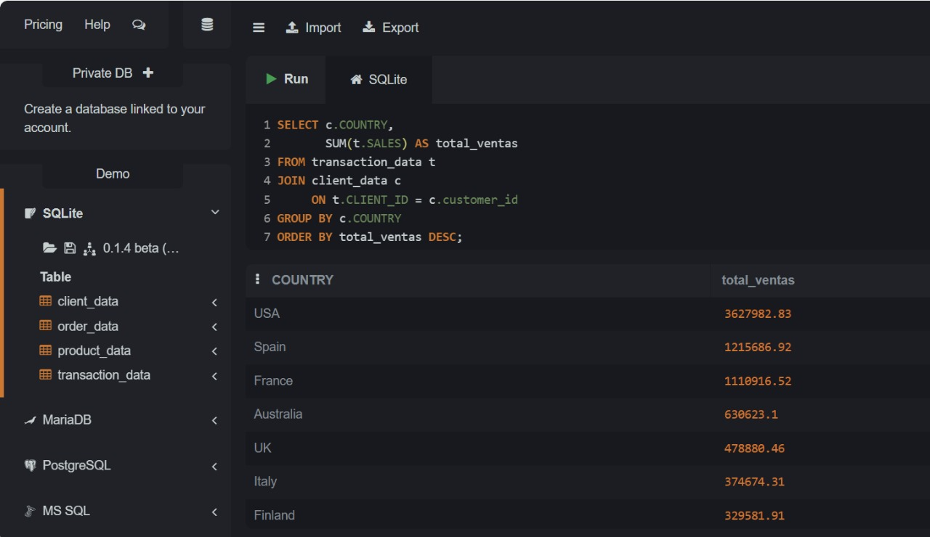

1. SELECT p.PRODUCTLINE,

AVG(t.PRICEEACH) AS AvgPrice

FROM transaction_data t

JOIN product_data p

ON t.PRODUCTCODE = p.PRODUCTCODE

GROUP BY p.PRODUCTLINE

ORDER BY AvgPrice DESC;

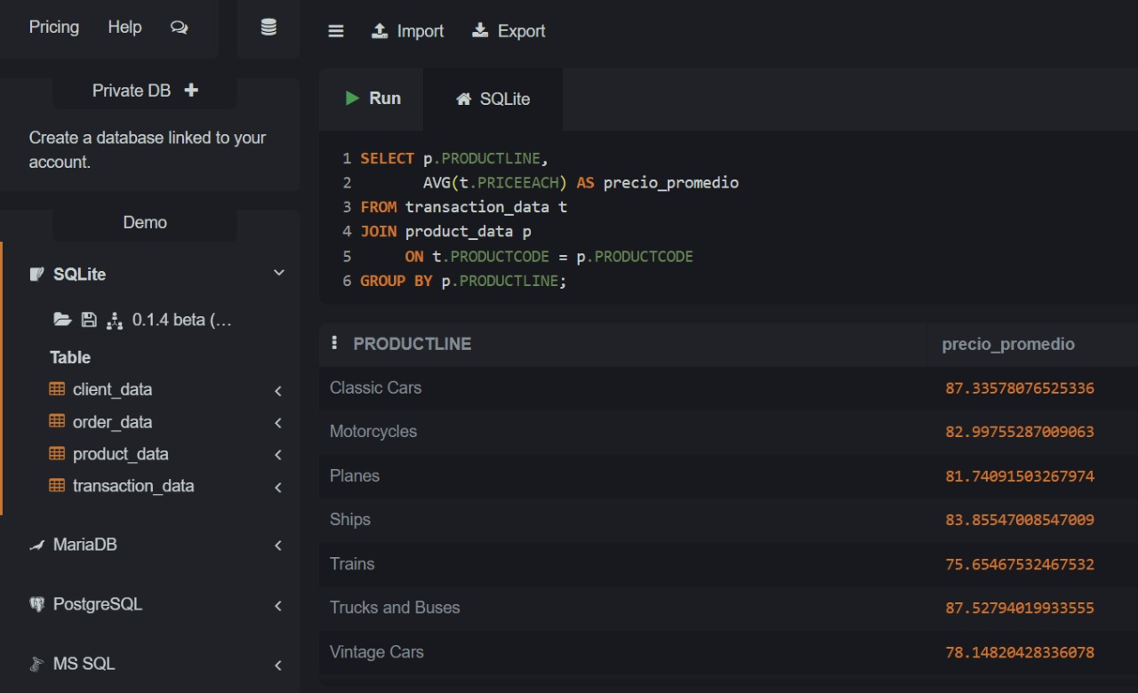

1. SELECT c.CUSTOMERNAME,

SUM(t.SALES) AS TotalSales

FROM transaction_data t

JOIN client_data c

ON t.CLIENT_ID = c.customer_id

GROUP BY c.CUSTOMERNAME

ORDER BY TotalSales DESC

LIMIT 5;

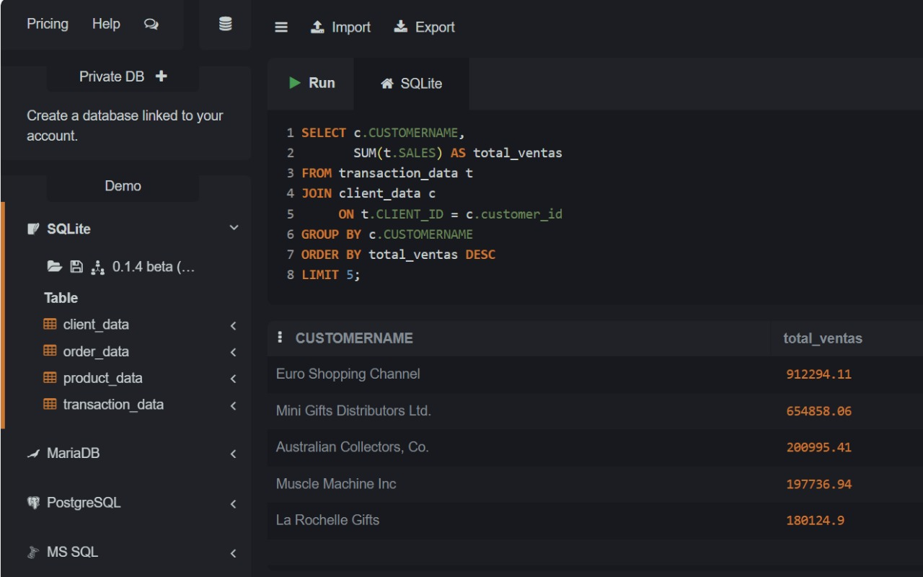

1. SELECT t.PRODUCTCODE,

SUM(t.QUANTITYORDERED) AS TotalUnits

FROM transaction_data t

GROUP BY t.PRODUCTCODE

ORDER BY TotalUnits DESC

LIMIT 3;

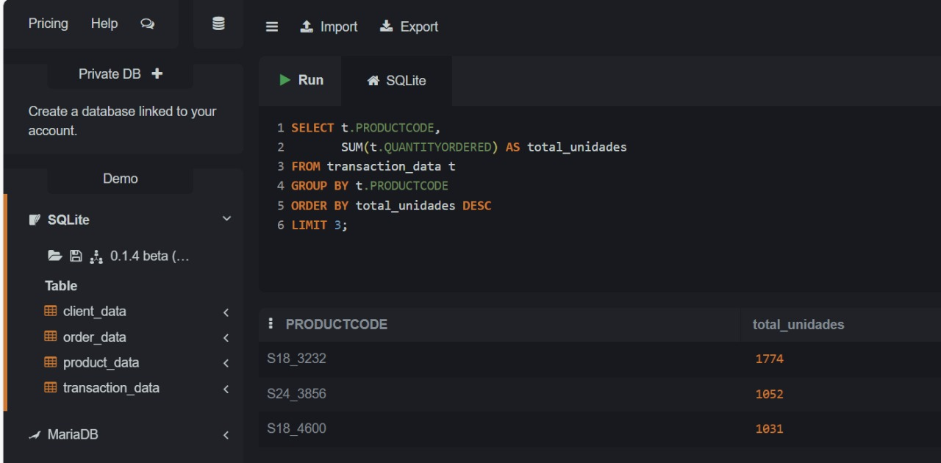

1. SELECT t.QTR_ID,

SUM(t.SALES) AS TotalSales

FROM transaction_data t

WHERE t.YEAR_ID = 2003

GROUP BY t.QTR_ID

ORDER BY t.QTR_ID;

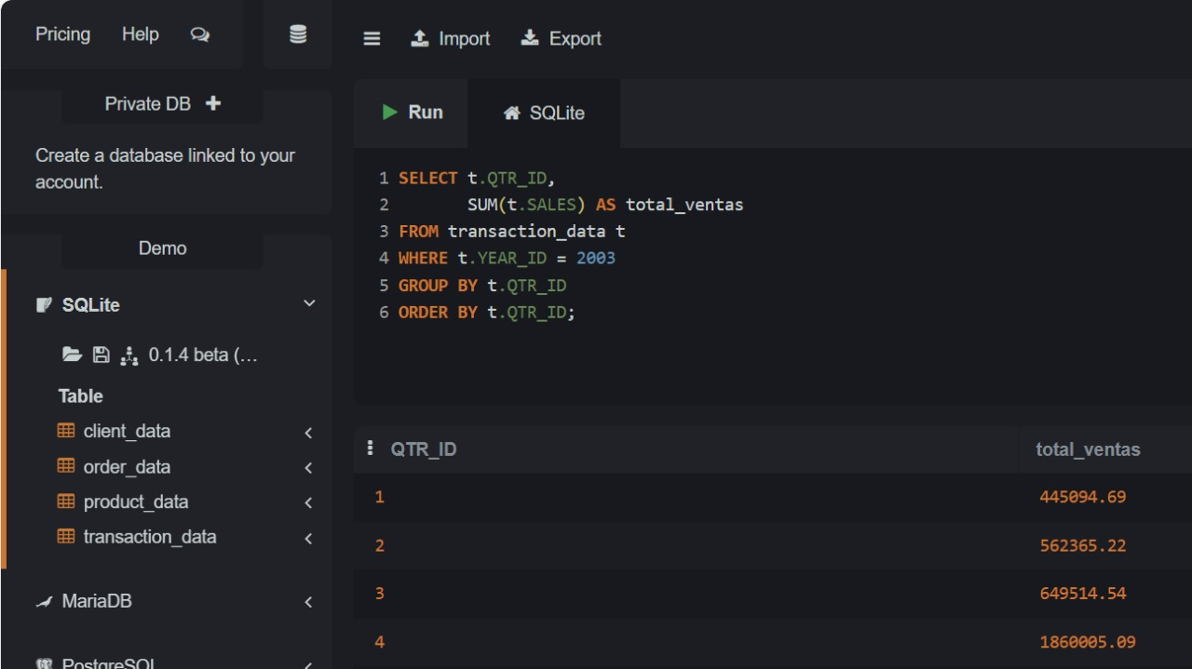

1. SELECT COUNT(*) AS TotalClientesEMEA

FROM client_data c

WHERE c.TERRITORY = 'EMEA';

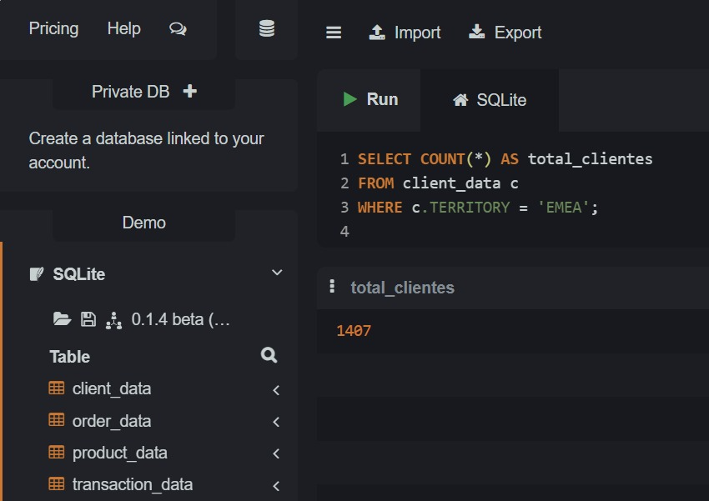

1. SELECT o.ORDERNUMBER,

c.CUSTOMERNAME

FROM order_data o

JOIN transaction_data t

ON o.ORDERNUMBER = t.ORDERNUMBER

JOIN client_data c

ON t.CLIENT_ID = c.customer_id

WHERE o.STATUS = 'Cancelled';

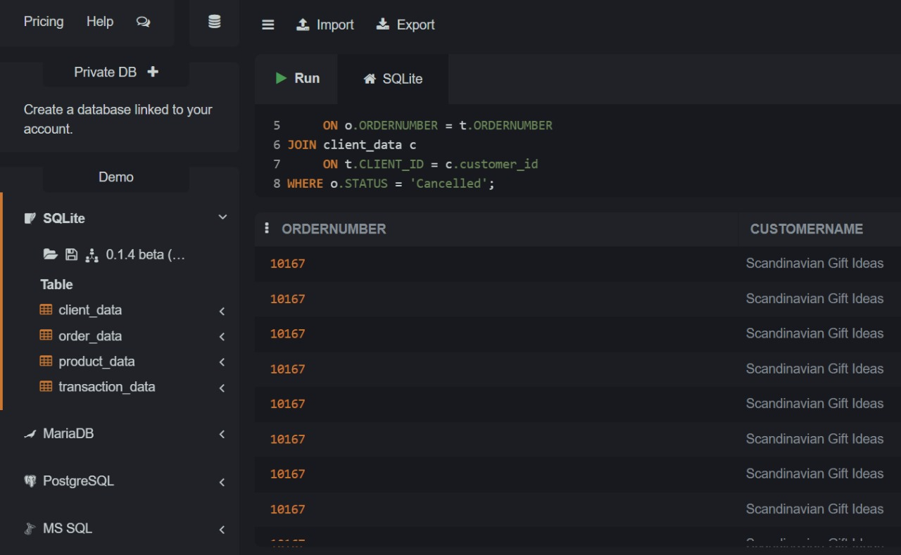

COMPLEJOS

1. SELECT t.YEAR_ID,

SUM(t.SALES) AS total_ventas

FROM transaction_data t

JOIN client_data c

ON t.CLIENT_ID = c.customer_id

WHERE c.COUNTRY = 'USA'

AND t.QTR_ID = 1

GROUP BY t.YEAR_ID

ORDER BY t.YEAR_ID;

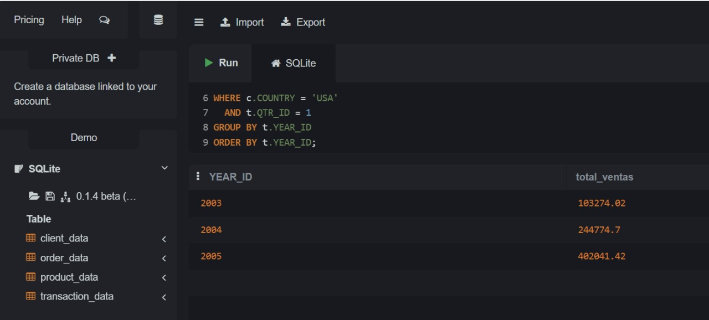

1. SELECT DISTINCT c.CUSTOMERNAME

FROM transaction_data t

JOIN product_data p

ON t.PRODUCTCODE = p.PRODUCTCODE

JOIN client_data c

ON t.CLIENT_ID = c.customer_id

WHERE p.PRODUCTLINE = 'Classic Cars';

